**CSCI 360 5. Using FileZilla to Download Marist Output**

**Allocate an Output Data Set**

If you do not have a data set allocated for your output, you will need to do so:

1. To reach the **Data set Utility** screen, enter option **=3.2** from the **ISPF Primary Option Menu**
2. Under the **ISPF Library** section, fill in the following:

**Project** your KC-ID

**Group** CSCI360

**Type** OUTPUT

1. Select option **A** to allocate a new data set and press [Enter]

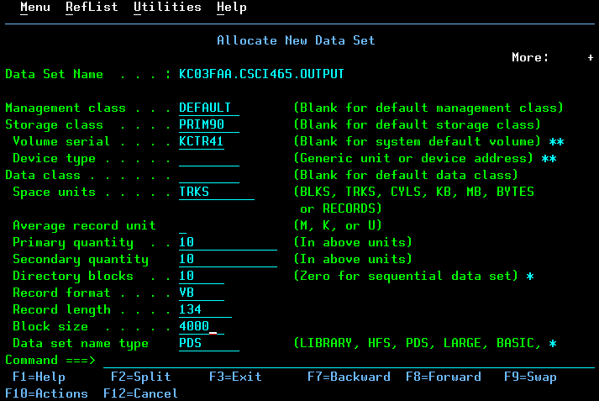

1. Allocate your data set with the following properties and press Enter.

**Space Units** TRKS

**Primary Quantity** 10

**Secondary Quantity** 10

**Directory Blocks** 10

**Record Format** VB

**Record Length** 134

**Block Size** 4000

You should now have a data set **KC03nnn.CSCI360.OUTPUT**.

**Saving Jobs on the Spool to Output Data set**

1. Once you have run a job, navigate to your output queue with the **=SD.ST** command.
2. Use the **XDC** command next to the output that you want to save

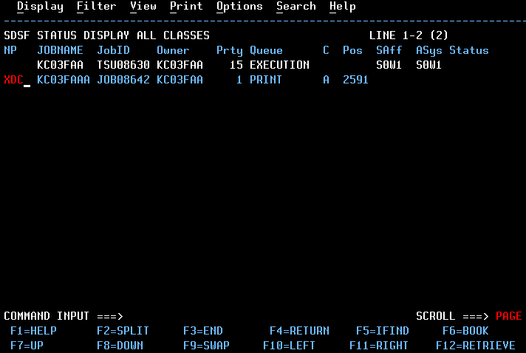

1. You will need to fill in the following fields:

**Data set name** 'KC03nnn.CSCI360.OUPUT'

Be sure to include the tick marks, and replace KC03nnn with your own KC-ID.

**Member to use** name of the output file

**Disposition** OLD

And press Enter.

1. You should now have your output file saved in your output data set. You can verify this by going to Option 2 on the **ISPF Primary Option Menu** and enter the following information under the **ISPF Library** section:

**Project** KC-ID

**Group** CSCI360

**Type** Name of output data set

**Member** Name of output file that you saved in step 3

**Using FileZilla to Download the Output File**

1. Download FileZilla from the following location and install it on your laptop or PC:

<https://filezilla-project.org/download.php?type=client>

1. Open FileZilla and enter the following fields in the **Quickconnect** toolbar at the top

**Host** zos.kctr.marist.edu

**Username** KC-ID

**Password** KC-ID password

1. Press the **Quickconnect** button.
2. Under the ‘Remote Site’ window on the right side, you should see your KC-ID with a plus box next to it. Click on your KC-ID and you should see a list of your data sets (with folder icons to the left) in the window below.

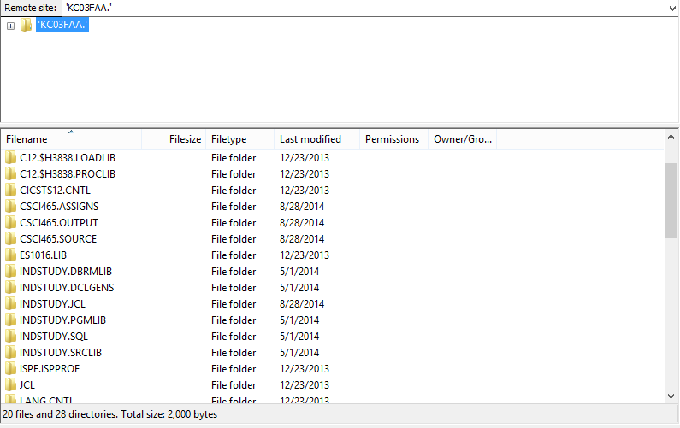

1. Navigate to your output data set in the bottom pane and double click it to open your data set. You should see your output files listed here. (Note that the above shows CSCI465 data sets instead of CSCI360 data sets.)
2. You can either drag and drop your output file to a local site, or you can **right click** the file and click **Download** (it will download the file to the Local Site location that is currently selected on the right side.

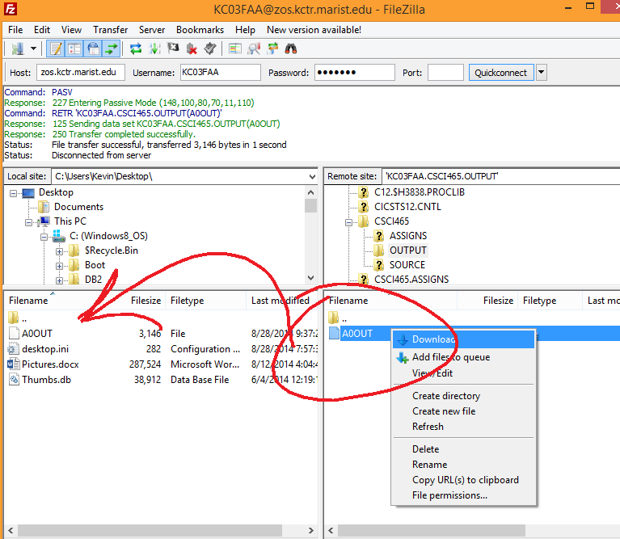

1. You can now open this file with a text editor like Wordpad or Notepad and verify that it is complete from top to bottom.